Victor Lam

Prof. Gummeson

ECE 331

20 November 2020

**Deliverables:**

Part I:

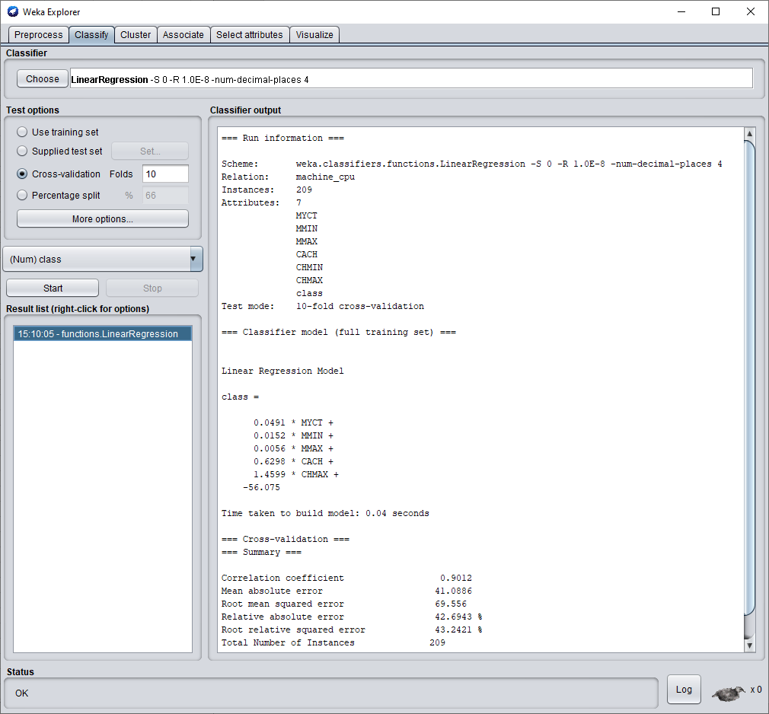

Part II:

i. Computing Y w/ Floating Point Numbers

|  |  |  |  |  |  |  |
| --- | --- | --- | --- | --- | --- | --- |
| Attribute | Weights |  |  | DATA_0 | DATA_1 | DATA_2 |
| W_MYCT | 0.0491 |  |  | 125 | 29 | 29 |
| W_MMIN | 0.0152 |  |  | 256 | 8000 | 811 |
| W_MMAX | 0.0056 |  |  | 6000 | 32000 | 16000 |
| W_CACH | 0.6298 |  |  | 256 | 32 | 32 |
| W_CHMIN | 0.0000 |  |  | 16 | 8 | 8 |
| W_CHMAX | 1.4599 |  |  | 128 | 32 | 16 |
| Offset_D | -56.075 |  | Prediction: | 335.6497 | 313.0193 | 90.7881 |

* Calculations done in Excel

ii. Computing Y w/ Fixed Point Numbers in Mars Simulator

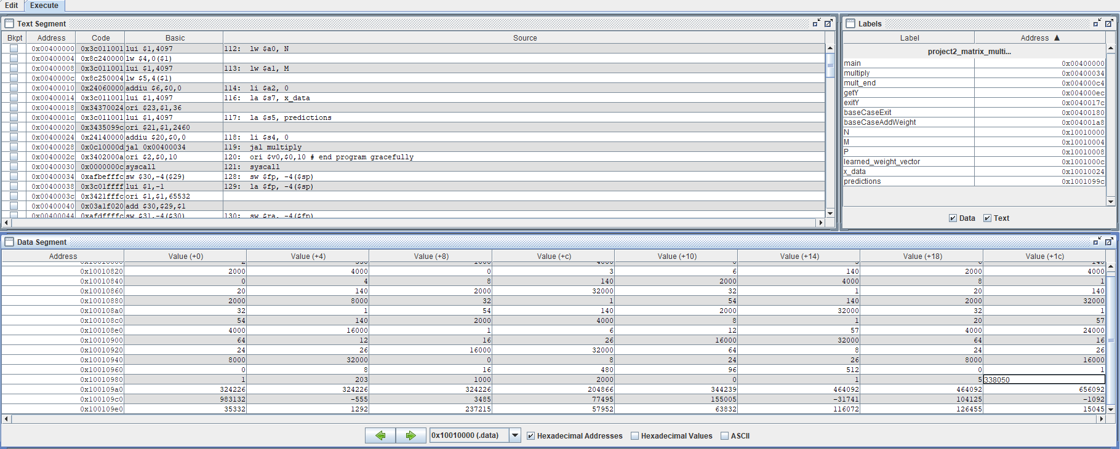

iii. Prediction Analysis

|  |  |  |  |  |  |  |
| --- | --- | --- | --- | --- | --- | --- |
|  | Results | |  |  |  |  |
| # | Floating-Point | Fixed-Point | Ground Truth |  | * Row #2 has 3 ground | |
| 1 | 335.6497 | 338.050 | 198 |  | truth values |  |
| 2 | 313.0193 | 324.226 | 269 |  |  |  |
| 3 | 90.7881 | 204.866 | 132 |  |  |  |

There appears to be a relatively small difference between the floating and fixed-point values for the first two predictions. However, on the third prediction, values appear to drastically differ. Below, is a “table” with the percent difference between the floating point (initial) and the fixed point (final) predictions.

|  |  |
| --- | --- |
| Percent Difference | |
| Floating-Point | Fixed-Point |
| 1% | -41% |
| 4% | -17% |
| 126% | -36% |

The calculated predictions compared to the ground truth value were pretty far off for the most part. The difference ranges from ~40 to ~137 for the floating-point prediction and ~55 to ~140 for the fixed-point prediction. The floating-point as expected was closer to the ground truth than the fixed-point prediction due to the higher accuracy maintained from not rounding off the decimal points. Below is a table with the percent error for both the floating-point and the fixed-point predictions as compared to the ground truth.

|  |  |  |
| --- | --- | --- |
|  | Percent Error | |
| # | Floating-Point | Fixed-Point |
| 1 | 41.0099% | 41.4288% |
| 2 | 14.0628% | 17.0332% |
| 3 | 45.3935% | 35.5676% |

Part III:

i-ii. Cache Configurations and Performance

|  |  |  |  |  |  |  |  |
| --- | --- | --- | --- | --- | --- | --- | --- |
| # | Placement Policy | Replacement Policy | Set Size (Blocks) | # of Blocks | Cache Block Size (words) | Cache Size (bytes) | Hit Rate |
| 1 | Direct Mapping | LRU | 1 | 8 | 4 | 128 | 77% |
| 2 | Direct Mapping | LRU | 1 | 16 | 2 | 128 | 66% |
| 3 | Direct Mapping | Random | 1 | 8 | 4 | 128 | 77% |
| 4 | Direct Mapping | Random | 1 | 16 | 2 | 128 | 66% |
| 5 | Fully Associative | LRU | 8 | 8 | 4 | 128 | 80% |
| 6 | Fully Associative | LRU | 16 | 16 | 2 | 128 | 65% |
| 7 | Fully Associative | Random | 8 | 8 | 4 | 128 | 76% |
| 8 | Fully Associative | Random | 16 | 16 | 2 | 128 | 62% |
| 9 | N-Way Set Associative | LRU | 2 | 8 | 4 | 128 | 76% |
| 10 | N-Way Set Associative | LRU | 2 | 16 | 2 | 128 | 66% |
| 11 | N-Way Set Associative | Random | 2 | 8 | 4 | 128 | 77% |
| 12 | N-Way Set Associative | Random | 4 | 8 | 8 | 256 | 91% |

iii.

Given the great number of computations, the size of the of the data must be very large. The data is also known to be sequentially stored in memory. This would appear to favor cache implementations with larger block sizes so that you miss less, but at the cost of having fewer blocks. However, the weight vector data is going to be accessed for every single computation, so to greatly reduce the number of misses, we should always keep that stored in the cache. This suggests a N-way associative cache with least recently used replacement policy will offer higher cache performance. We should still keep the number of blocks lower with a larger size to take advantage of the data all being stored sequentially in memory. The easiest way to reduce miss rate is to increase overall cache size, which is what I did in the last trial to break the 90% hit rate threshold.

iv.

